**EDIT Tool Widgets for One VM Project Website**

***(Updated)***

Christopher Grasteit

& Neha Chudiwale

* Appendix A: *Geodatabase Schema*
* Appendix B: *Edit examples/process flows*

The Smart Edit widget provides capabilities using the Project polygon editable layer in a feature service. It displays a gallery of templates from one or more feature layers(if available). Optionally, you can enable the Edit toolbar for advanced feature editing.

***There have been workflow changes with regard to the EDITOR, Please review this.***

On the map, to create a new feature you pick the symbol on the template using Smart Edit widget then update the information with the associated attribute inspector. Another option is to select an existing feature and update its geometry and/or attributes. If the feature layer has related features from other layers, you can edit those features and ensure the relationship is inherited.  If the feature layer supports attachments, you can create, view, and delete attachments. Optionally, you can enable the toolbar for advanced feature editing.

* **Use feature template filter**—Filters to find the feature template.
* **Toolbar visible**—Displays the Smart Edit and Edit toolbar.
* **Toolbar options**—Allows you to use geometry creation in the **Smart Edit** and modifying operations via the **Edit** toolbar which allows selection of features, clear the selection, and delete features (by selection).
  + **Merge**—Allows you to combine two or more polygons into one single feature.
  + **Cut**—Allows you to split a polygon or feature into two separate features.
  + **Reshape**—Gives you the option to change the shape of a geometry on the map

**Use of the Smart Edit widget**

* + 1. Open the Smart Edit widget to display the template picker.

Smart Edit Tool

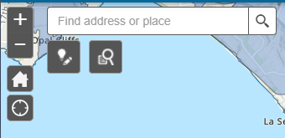

* + 1. To add a new Polygon feature, click the **VegProject_PolyEdit** shape and then click the bottom shape to pull up collection of shapes. Click the type of shape you want to add. This is located at the Pulldown at bottom.  
       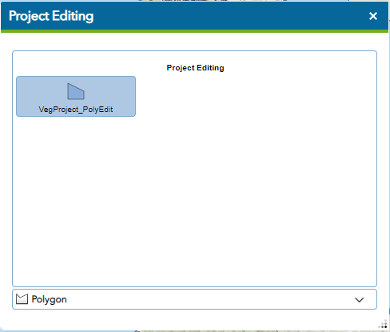

Click a location on the map to start drawing whatever shape you’ve chosen, a polygon for example. To create the correct shape for the polygon, click the different locations where you want the polygon outline to go. Continue clicking locations to create the correct polygon shape. When you reach the end point, double-click to close the polygon and complete the drawing.

* + 1. To update/edit an existing feature, click on the polygon you wish to edit. **Second-click on the feature to display its vertices**. Move the vertices to create the shape you are looking for. Once you've completed the changed feature, a pop-up appears. Enter information or changes in the available fields. The fields available may vary based on the editable attribute fields in the feature service and the configuration of the editable layer. By default, each input to the field is automatically written to the feature service.

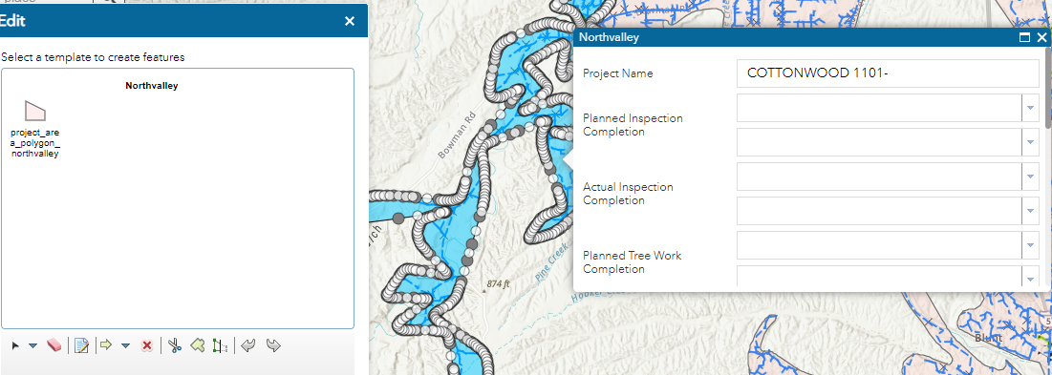

* + 1. At the bottom of the Attribute Inspector you will find buttons including **Save**. Updates made to the fields will not apply until you click **Save**. Selected features can be deleted.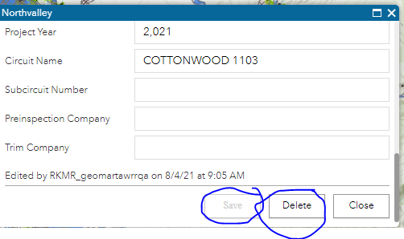
    2. Alternately to remove a feature, click it on the map to open its pop-up. Click on the three dots “…” in the lower left corner of popup. Select **Edit** and click and select the red X or if in Attribute box hit the **Delete** as shown above**.**

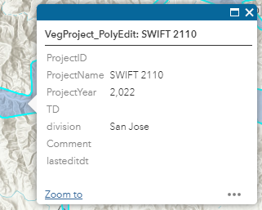

* + - Advance Feature Edit toolbar options:  
      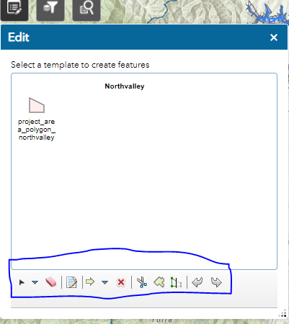

Unselect

Attributes

Cut | Union | Reshape

Toolbar Options

Draw Feature

Undo/Redo

Delete

Selection

**Toolbar options**—Allow you to use geometry modifying operations via the editing toolbar to select features, clear the selection, and delete features (by selection).

* + - * **Attributes** Opens popup for selected features values
      * **Join/Union** Allows you to combine two or more polygons into one single feature. The first polygon selected Attributes will remain.
      * **Cut** Allows you to split a polygon or feature into two separate features. The attributes will be shared across the new polygons.
      * **Reshape** Gives you the option to change the shape of a geometry on the map. You may need to reshape an existing line or polygon feature. To do this, double-click the feature to display its vertices. Choose the vertex needed to reshape the feature and drag it to its new position. Once you click off the feature, the edit is saved
      * **Undo/Redo** Allows you to Undo or Redo edit actions.
      * **Delete** Removes a feature

**Appendix A**

Below I have listed all fields in the Project polygon table. Depending upon how you are accessing the information you may see less information.

**All Field Attribute Information**

14 Fields

Object ID *System Maintained*

Circuit Name Editable Circuit Name

Division Editable PGE Division where Circuit is located.

GlobalID *System Maintained*

ProjectID Editable Numeric Project ID

ProjectName Editable Project Name

Project Year Editable Numeric four digit year.

TD Editable T or D code based on transmission type.  
Comment Editable This can be anything noteworthy like name or initials.

Lasteditdt Editable Date of last edit performed. This is shape, attribute or both.

GlobalID_2 *System Maintained*

Shape_Area *System Maintained*

Shape_Length *System Maintained*

Shape *System Maintained*

**Appendix B**

**Edit Examples**

**Update Attributes:** Update the values in the database for a select Project area.

1. Click on a Project polygon you wish to update database values on. A popup should appear.
2. Click the three dots “…” and select Smart Editor from the list menu.
3. Make the Updates or Changes necessary. Be sure after your update to click on another field to complete the update.
4. Click the SAVE button at the bottom of the popup and your done.

**Create New Project:** Add a new Project.

1. In the upper left hand of the web map is a button with a light bulb and a pencil below it. Click it and a popup will open. This is the Smart Edit tool and the best tool to create a Project polygon.
2. Click the icon with “VegProject_PolyEdit” under it.
3. At the bottom of the popup you’ll see another option that has a picture of a polygon and down arrow. Click the down arrow and a list of types polygon to create will show up. Select the type of polygon to build.
4. Now click on the map where you want to start your new polygon.
5. Depending on the tool the Intellisense will guide you to build the new polygon. When building a simple polygon you can snap along the edge or vertices by holding down the CTRL key and looking for the light blue “x” along the edge or point you want to anchor along. Upon completion double click to complete the polygon.
6. It’s important to go over to the blank form in the popup and fill out what you need. Make sure once you fill out the last field that you click on another field to complete your entry.
7. When complete click the SAVE button. Your addition including information about it are complete.

**Clipping**: To Cut/Clip a large Project area into two or more smaller areas use the following workflow.

1. Start by making sure the Smart Edit popup is closed. It will read “Project Editing” in the top bar.
2. Click on the polygon you want to Clip. It should have a blue line around it and a popup showing information about the selected polygon.
3. Click on the three dots “…” in the lower right hand corner. An item list will pop up. Select “Edit” from that list which will popup the “Editor Tool”.
4. From the bottom list of icons in the Editor Tool select the scissor icon.
5. Click just outside of the area you wish to cut/Clip. This will start the line that will clip the area. You will be prompted next to the cursor with Intellisense prompts to help.
6. Click inside the selected area you are cutting as much as you want to shape the cut.
7. To complete the cut, take the line again to just outside of the opposite side of the selected area and double click.
8. ***NOTE****: After Clip the two new split polygons will contain the values from the original area.*
9. Upon completion the Attribute list will popup showing the values for the selected clipped side of polygon. Make changes to the attributes needed. If you don’t make any then close the attribute popup.
10. To complete the operation, click on the other side of the cut polygon which should select it and popup again with the attributes. Make changes and when completed click on another field to set the last changes. Click the SAVE button which should now be highlighted.
11. Close the Editor Tool if you are completed with your editing.
12. You have now completed a CLIP and verified and/or changed values for each new polygon.

**Delete**: Deleting a Project polygon is a straight forward operation.

1. Select the Project polygon you wish to delete on your map. You should see a cyan/blue outline on what is selected.
2. If what you have selected has another Project polygon under or overlapping where you have clicked you need to distinguish which polygon you want to delete. In your information popup, on the top blue bar you will see the number of polygons you have clicked on, eg. (1 of 2). Use the < or > at the top to move the selection. You’ll see the cyan/blue outline move to each polygon you are looking at.
3. With the Project polygon selected that you wish to delete click on the … in the right hand corner and select “EDIT” from the popup menu.
4. At the bottom of the Editor Tool that has opened you will see an **X**. Click it and your selected Project polygon will be deleted.
5. ***Note:*** *If you accidently deleted the wrong polygon you can bring it back by using the Undo tool. This is at the bottom of the Editor Tool far right, you’ll see two arrows for Undo and Redo.*